
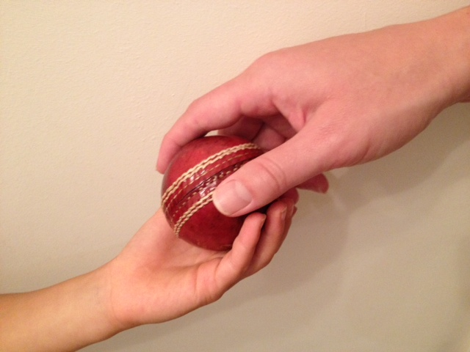

STANDING ORDER MANDATE

Please return this form only directly to your bank or return to
Angela Durndell, Warwickshire Cricket Board, the County Ground,
Edgbaston, Birmingham B5 7QU with your reply slip
To My Bank Manager

Bank Name

Bank Address

Bank Account No

Sort Code

Please Pay

Payee Bank Name | Lloyds TSB Bank plc
Payee Account Name | Warwickshire Cricket Board Limited
Payee Sort Code | 30 19 14
Payee Account Number | 01329603
Payment Amount | £3.00
Frequency | Monthly
Date of First Payment | (please insert)
Reference | Friends of Warwickshire Youth Cricket
Your Details

Name

Address

Signature

Print Name

Friends of Warwickshire Youth Cricket Reply Slip

I confirm that I would like to join “Friends of Warwickshire Youth Cricket” and have completed the “Standing Order Mandate”

Name: ______________________________________________________________________
Contact No(s): ________________________________________________________________
Address: ____________________________________________________________________
Email: _______________________________________________________________________

This reply slip should be completed and returned to Angela Durndell, Warwickshire Cricket Board,
The County Ground, Edgbaston, Birmingham B5 7QU
Or email your reply slip (only) to angeladurndell@edgbaston.com

It is Warwickshire Board/Warwickshire CCC policy to only disclose information to third parties if explicitly required to do so by United Kingdom Law. Warwickshire Cricket Board/Warwickshire CCC will obtain your consent before passing on any information to any third parties. Warwickshire Cricket Board/Warwickshire CCC does not collect or compile personally identifying information for dissemination or sale to external parties for marketing purposes or host mailings on behalf of third parties.
Belonging to the Friends of Warwickshire Youth Cricket is a great chance to join together with other Warwickshire followers and cricket lovers in showing your support for the future generation of young cricketers coming through the Warwickshire youth system.

In order to maintain and extend the range of cricket teams and facilities to boys and girls in the County, the Warwickshire Cricket Board is asking you please for a small monthly contribution of £3. This will enable you to be the first to see and hear about the next exciting young players likely to break into the full County sides.

As a Friend of Warwickshire Youth Cricket you will receive;
- Regular newsletters and correspondence during the season by email, providing information on Warwickshire Youth Cricket results, fixtures, analysis and development initiatives,
- Two invitations a year to join other ‘Friends’ at WCB matches (one girls, one boys), where refreshments will be provided,
- The opportunity to win a one-to-one coaching session with a Warwickshire player or coach for yourself, a family member or friend.

In Warwickshire, our young cricketers, their families and their coaches put a great deal of time and energy into representing their County on the cricket pitch. If you are able to support them by joining the Friends of Warwickshire Youth Cricket, please complete and return the form below. Our aim is to ensure that all the opportunities they currently enjoy can be preserved and improved. Thank you.

If you have any questions about the Friends of Warwickshire Youth Cricket
please email your questions to friends@edgbaston.com

It is Warwickshire Cricket Board/Warwickshire CCC policy to only disclose information to third parties if explicitly required to do so by United Kingdom Law. Warwickshire Cricket Board/Warwickshire CCC will obtain your consent before passing on any information to any third parties. Warwickshire Cricket Board/Warwickshire CCC does not collect or compile personally identifying information for dissemination or sale to external parties for marketing purposes or host mailings on behalf of third parties.

FRIENDS OF WARWICKSHIRE YOUTH CRICKET

